Chapter 1
IN THE BEGINNING 1895 – 1917
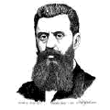

”We shall try to spirit the penniless population across the
border by procuring employment for it in the transit countries,
while denying it any employment in our own country ....
Expropriation and the removal of the poor must be
carried out discreetly and circumspectly."
Theodore Herzl
Founder of “Zionism”

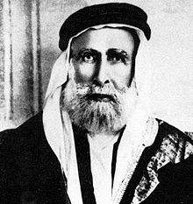

As leader of the Great Arab Revolt Sharif Hussein declared independence
from the Ottoman Empire in June 1916 and was to become King of the
Arabs including Palestine.
Sayyid Hussein bin Ali
Sharif and Emir of Mecca

Mark: Hisham, it seems everyone is still talking about the “Two-State Solution” after so many years. Some people say it’s dead and over; some governments say it’s here and now. Whatever, the “Two-State Solution” has become a recurring phrase in our political rhetoric. And our own lives have both been partly defined by this seemingly unending conflict. I was born an American Jew and some of my earliest memories are the singing of “Hatikva,” the Israeli National Anthem, at the end of every Passover dinner. You were born in a Palestinian refugee camp, literally born into this conflict. So Hisham, from your perspective, how and when did it become a conflict requiring a solution?

Hisham: Mark, I would wake up every morning in my youth with the howling ghost of the Israeli occupation looming over the heads of my family. The roots of the conflict, of the occupation itself, date back to the early Zionist immigration to Palestine, which occurred primarily in the second half of the 19th century. It was during this early immigration that Palestinians first felt that there was some foreign force vying to take their country from them.

The first actual Zionist settlement was established in Palestine in 1882, even before Theodore Herzl's famous book.

It was in 1895 that The Jewish State and subsequently convened the first World Zionist Conference in 1897 in Basil, Switzerland. That was when the Palestinian people began to realize that there was real danger coming their way. Both Herzl's book and the conference made it clear that Zionism was established to provide a state for the Jewish people and to outline a strategy for the unification of Jewish political and economic power to that end. Really, Mark, the goal from the start was to take Palestine from the Palestinians.

Mark: I recall that Herzl, in The Jewish State, wrote that the Arab population living in Palestine; the “penniless peasants” as he referred to them, would be forced to leave one way or another.
The percentage of Jews living in Palestine at that time was quite small. I don’t think more than 50,000 Jews lived there; most of whom were religious and non-Zionist Jews, living mainly in the Jerusalem area.

If such a small population of Jews were in Palestine, then how in the world did the Zionist movement catch on as it did, and what was the initial reaction from the Palestinian population?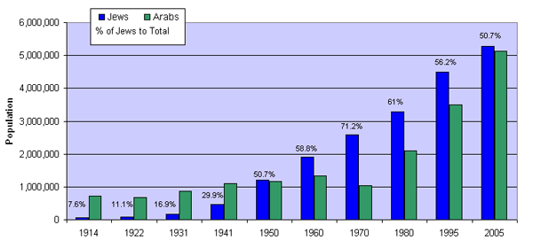

Jewish and Arab population growth in Palestine/Israel from 1914 to 2005
http://israelipalestinian.procon.org/view.resource.php?resourceID=636&print=true

Hisham: The Zionist movement was able to make inroads in Europe right away because of Christian anti-semitism. The Zionists had a real reason to fight back and push for drastic measures. Then, during World War I, the Zionist movement was able to manipulate the politics of the war years to its advantage. The movement clearly understood that the European nations were totally preoccupied with the war itself. This preoccupation and involvement in the war would soon lead to covert operations designed to manipulate the outcome in the Middle East when the European victors replaced the Ottomans. The Zionists also understood that the idea of the nation-state could be exploited for their own ends. In fact, the Zionist movement had signaled to both Germany and Great Britain that whoever came to the aid of the Zionist cause could expect help and support from powerful and wealthy Jewish businessmen and bankers.

Mark: The Zionists even went to the Ottomans as well before it was clear who would win World War I. They really played all sides.

Hisham: Yes they wanted to make sure they were partnered with the winners. There were also important Zionist persons, such as Chaim Weizmann, who invented a very important new type of explosive that was soon used extensively by the British in their war effort. There were also Zionist bankers who supported the British war effort.

It wasn’t just the British. The Zionists truly manipulated the United States as well. The United States was in a period of isolationism. Most Americans had no desire to involve their country in the European war, but the Zionists wanted American help and support for their cause. The Russians meanwhile, due to the Bolshevik Revolution of 1917, pulled out of the war in the months before the British Government published The Balfour Declaration on November 2, 1917.

The Balfour Declaration was greatly celebrated by the Zionist movement which saw it as the first major international step toward creating a Jewish State in Palestine. The British felt that there was a terrible power vacuum on the Eastern front, and they were keenly aware of the severe losses they were suffering due to Germany's U-Boat campaign in the Atlantic. It was at this time that the Zionists sent their emissaries to the British to suggest that the British were in a vital position to convince the United States to enter the war on their side, and they could help each other.

In addition to putting pressure on the U.S. through the British, the Zionists also worked inside the U.S. They looked to Louis Brandeis, then a Jewish Justice on the U.S. Supreme Court and a close friend of President Woodrow Wilson. It was Brandeis personally who helped convince Wilson that the U.S. must intervene in World War I.

In this way both the British and the Americans became supportive of the Zionist movement and this is the context in which The Balfour Declaration was issued. In fact Brandeis himself personally presided over the very careful drafting of the Balfour Declaration. He went over some 33 revisions I believe, closely coordinating at every step with both the U.S. and U.K. governments.

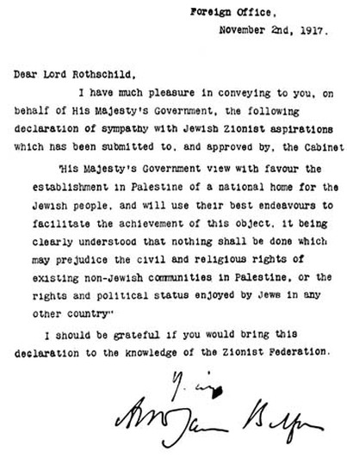
The BALFOUR DECLARATION – 2 November 1917

That Declaration really shook the whole world. Immediately Palestinians demonstrated against it. In a very real sense, the Balfour Declaration was the first trigger of the conflict that has persisted ever since.

Mark: I think it’s also important to remember that the Zionist leaders at the time were mostly secular and mostly integrated into the European system, not ostracized from it. Herzl, author of The Jewish State, was not a religious Jew. These secular and integrated Jews, like Brandeis, were the champions of the original Zionist movement. They, as you said, were able to exploit the war years because of their close relationships to political officials, financial clout, and growing determination to make Palestine a Jewish State, though at the time they didn't state that in public. In fact, in public, they continually denied that that was their goal.

Also at the time, both the British and the French were also maneuvering to get Arab support for the war while at the same time plotting behind the backs of the Arabs for what would happen to the region after the war.

This was the period of Lawrence of Arabia, of the McMahon-Hussein correspondence, of the secret Sykes-Picot Agreement…as well as the public Balfour Declaration.

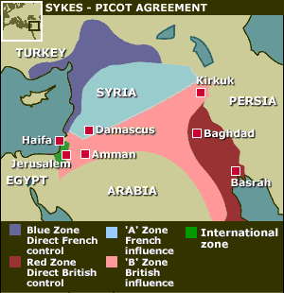
Map: Sykes-Picot Agreement - 1916
http://news.bbc.co.uk/hi/english/static/in_depth/world/2001/israel_and_palestinians/key_maps/7.stm

Then, when the war ended, you had the Paris Peace Conference followed by the San Remo Conference and other international conferences as well…all designed to legitimize European colonialism in the region and prevent the greater “Arab State” the Arab leaders were then not only dreaming about but demanding.
Then in 1922 there was what was called the Churchill White Paper as well. All of these agreements, declarations, conferences and papers had to do in one way or another with the future of Palestine – on the one hand deceptively reassuring the Arabs, and on the other hand cooperating with the Zionists.

In those days there was no discussion of any kind of “Two-State Solution” because it seemed to everyone that Palestine was Palestine and the various communal concerns would somehow be resolved and accommodated one way or another.

I think it’s important to remember that, at the time, the whole world called the area Palestine. Even the Zionist leadership kept insisting that they had no intention of establishing a “Jewish State” in Palestine, despite what Herzl had said. Today the major Jewish newspaper called The Jerusalem Post was actually called The Palestine Post when it was founded as late as 1932 by an American Jewish Zionist.

Hisham, at the time of the Balfour Declaration and as World War I was coming to an end, what were the Palestinians doing?

Hisham: They were in a state of shock, Mark. . It had become alarmingly evident that the British now viewed Palestine as part of their own territory. The Palestinians felt their existence was in danger, so they protested. These were a tranquil people, living on their land as they had done for thousands of years. It was clear from the beginning that the Zionist 'Colonial Project' was making headway against the Palestinians, but nevertheless the Palestinians never succumbed, never acquiesced. They resisted from the time of the Balfour Declaration, in 1917 into the 1920's.

Mark: Hisham, I have a telling quote from the 1919 Paris Peace Conference, from the official Zionist representative at that time. “It has been said and is still being obstinately repeated by anti-Zionists again and again,” Nahum Sokolow said, “that Zionism aims at the creation of an independent ‘Jewish State.’” “But this is fallacious,” he continued, “The ‘Jewish State’ was never part of the Zionist programme.”

So, they were officially saying to the Arabs, to the Palestinians, and to the world, even after the Balfour Declaration, that there was no reason for Palestinians to fear losing their country, that the Jews just wanted to live in peaceful coexistence with the Arabs who were by far the largest population group in the country. In those days, it was common for Zionist representatives to keep reassuring the Palestinians that the goal was not a Jewish State. In retrospect, of course, it’s now realized such an approach was designed to mislead, confuse, divide, and pacify the population. It also gave the British an excuse to allow growing Jewish immigration into Palestine.

Also very important at this time came the so-called “Mandates” which were legitimized by the League of Nations. The “Mandates” related to the way in which the League of Nations planned on dividing the territory of the former Ottoman Empire and in a sense were an extension of the Sykes-Picot Agreement.

Much of the territory of the former Ottoman Empire came under this system of “Mandates.” That’s how the British would legitimize their control of Palestine and also how the area east of the Jordan River was turned into Transjordan under the rule of a Hashemite Emir whom they made into a King.

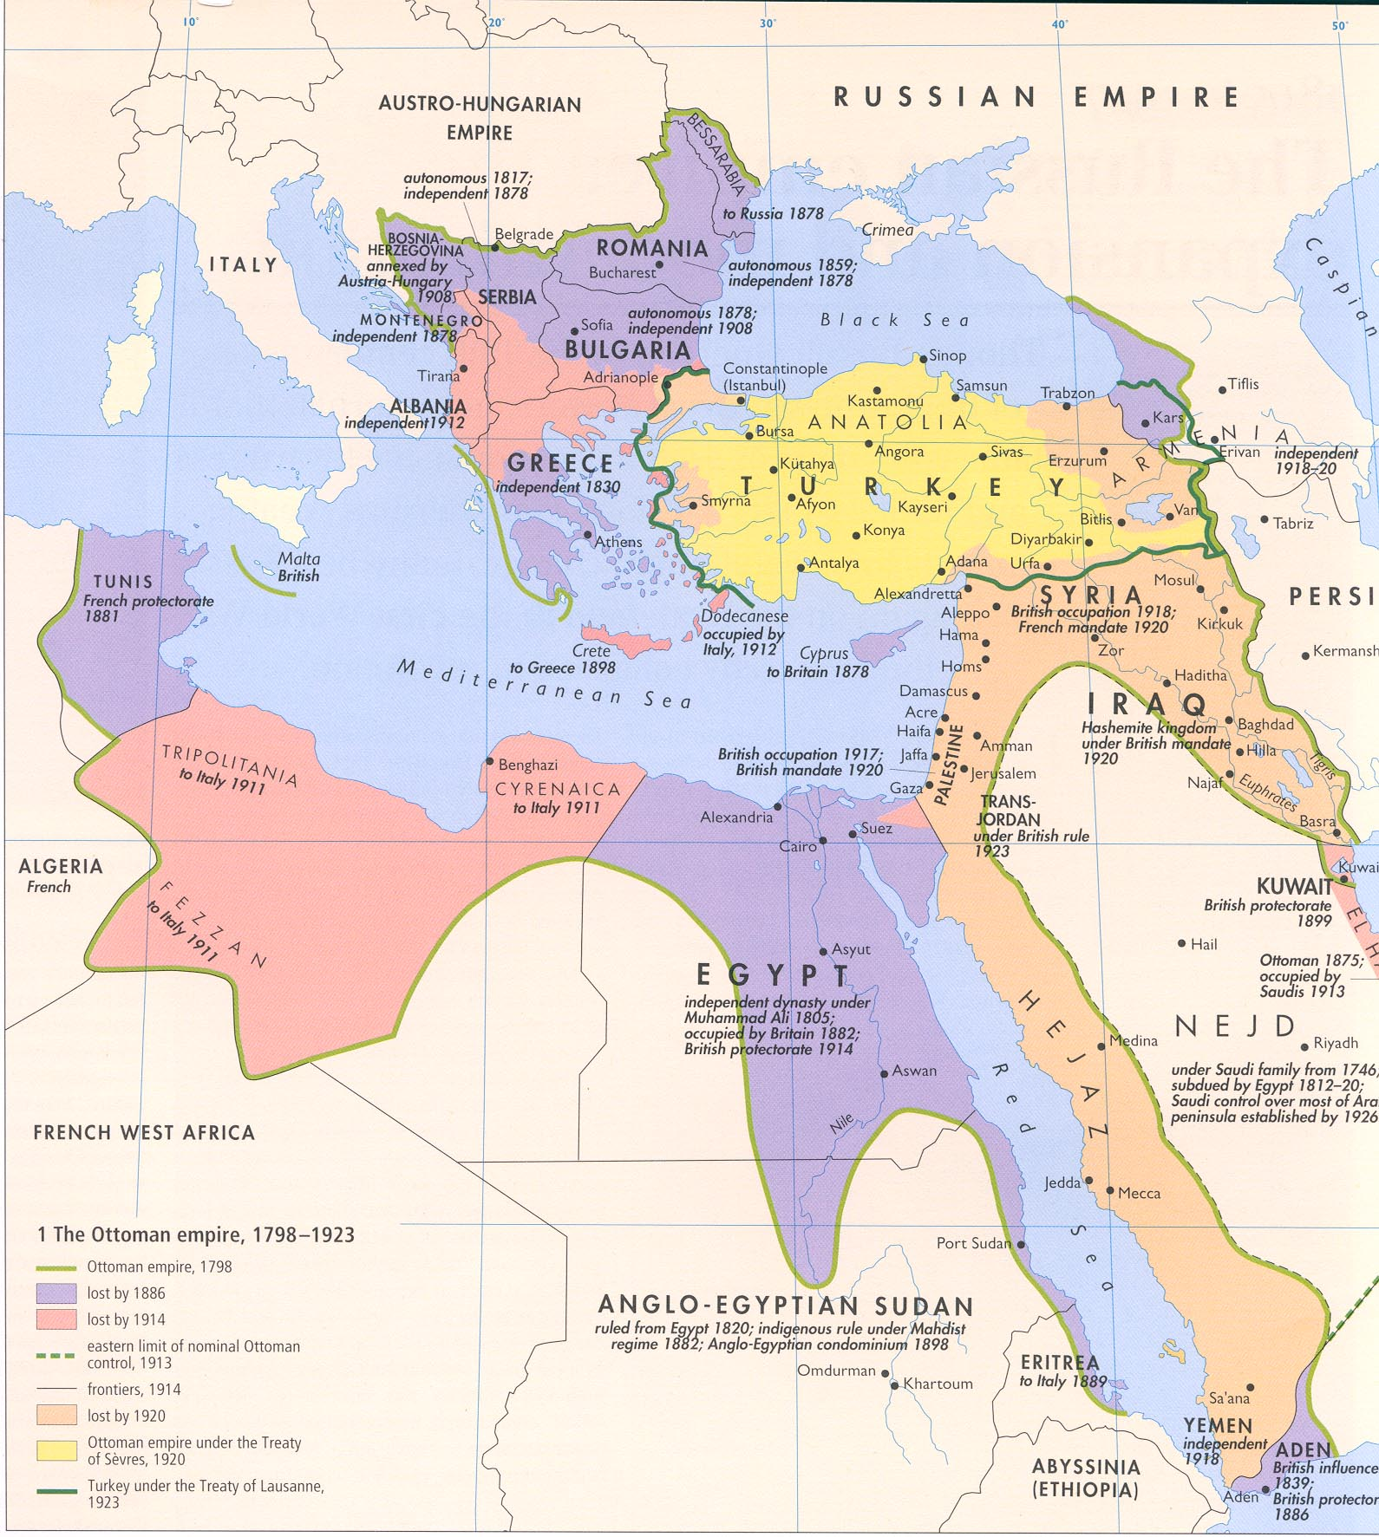

Hisham: I view the Mandate, or “Mandates,” as forbearance for the colonization of Palestine. The British marched their troops into Palestine in 1917 and that’s when the British occupation began. In 1919, even though Woodrow Wilson had for the most part succumbed to Zionist dictates, he did send an American Commission to investigate the situation in Palestine. The Commission was called The King-Crane Commission. In the summer of 1919, those on The King-Crane Commission sent many telegrams to Wilson advising him that the Palestinian people vehemently opposed both the Zionist project and the British mandate. Their report was suppressed for three years. Nevertheless, it was important because it illustrated the widespread opposition to the British mandate and to the Zionist colonization of Palestine from the start.

"An International Commission was projected…to study conditions in the Turkish
Empire with reference to possible mandates. The American Section of that Commission
is in the Near East simply and solely to get as accurate and definite information as
possible concerning the conditions, the relations, and the desires of all the peoples
and classes concerned in order that President Wilson and the American people may
act with full knowledge of the facts in any policy they may be called upon hereafter
to adopt concerning the problems of the Near East-whether in the Peace Conference
or in the later League of Nations.”

King-Crane Commission
Statement of Mission, 1919

Mark: There is another historical moment I recall of some significance I think. When the British commander, General Allenby, marched into Jerusalem, London ordered him to not ride in on horses and not to prominently fly the British flag and certainly not to demonstrate support for Zionism. So, instead, he paraded into Jerusalem on foot down the same central street still named for him today. As I recall, even without the fanfare, the Arab notables of Jerusalem cautiously gathered to hear Allenby give his speech and there was little enthusiasm and much apprehension right from the start. So, even then, the political and nationalistic sensitivities were very well known and understood, it seems.

Hisham: This was a period of shock for the people of Palestine. They had been living in their own country and suddenly this invading power came to violently take their country from them, and sought to erase and negate their cultural and national identity.

There are incredible stories about how people resisted the occupation in those early days. In fact, there is a story that was related to me by my father. Although this touches on a later period, during the 1940's, it's an excellent example. In his home town of Zakariyya, my father was approached by a high ranking British officer while farming the land. The tall, white man walked up to him my father and asked him how to eat the local cactus fruit.

My father gestured to the officer (as my father does not speak any English) that you simply pick it up and eat it. But what my father did not tell the officer was that cactus needs to be first cleaned from the prickly thorns and then peeled before eating. My father was basically exercising his own way of getting back at the British.

Mark: Well Hisham, the Palestinian rebellion really started a long time ago then. So, the popular idea that the “first” Intifada only started in the late 1980's is not entirely accurate. It sounds like the Intifada -- the rebellions, the uprisings -- really started right at the time of the Balfour Declaration and the British occupation at the end of World War I. The uprisings were well underway by the time your father had his little run in with the British officer. So, how did the actual resistance to British occupation and the Balfour Declaration progress? What happened in the 1920's? What happened from the Palestinian perspective?

Hisham: During this period, there was constant resistance against the constant Zionist expansionary polices of taking the land and bringing more European Jews to Palestine.

Mark: And then in 1929, a much more violent reaction?
Hisham: That was called the “Buraq” uprising. The Zionists tried to claim a very holy Muslim site and sparked one of the first major Palestinian rebellions. The rebellion continued for years and led to the largest and the longest Palestinian uprising, which lasted from 1936 to 1939. The Buraq uprising temporarily succeeded in pressuring the British to try new diplomatic steps aimed to soothe the Palestinians and restrict the Jewish Zionists.

Mark: Alright, this then, in broad strokes, is the origin of the conflict we are still living with today. You’ve really helped me understand how the origins of what we call the Intifadas of our own day really began back then. And also my own country was far more involved through President Wilson and Supreme Court Justice Louis Brandeis then I realized even though nearly all the major Jewish organizations of the time were actually skeptical and in most cases opposed to Zionism, fearing that the loyalty of American Jews to the US might be questioned. Most American Jews at the time were busy integrating into American society and not thinking about or wanting a “Jewish State”.

MAB – 1 March 2012
HA – 7 March 2012

